brief behavioral health
PATIENT ASSESSMENT

Patient Name: DOB:

This questionnaire is an important part of providing you with the best health care possible. Your answers will help in understanding problems that you may have. Please answer every question to the best of your ability.

1. Over the last 2 weeks, how often have you been  bothered by any of the following problems? | Not at all | Several days | More than half the days | Nearly every day
a. Little interest or pleasure in doing things | 0 | 1 | 2 | 3
b. Feeling down, depressed or hopeless | 0 | 1 | 2 | 3
c. Thoughts that you would be better off dead or of  hurting yourself in some way | 0 | 1 | 2 | 3
d. Feeling nervous, anxious, or on edge | 0 | 1 | 2 | 3
e. Not being able to stop or control worrying | 0 | 1 | 2 | 3

2. For Females, “How many times in the past year have you had 4 or more drinks in a day?”
For Males, “How many times in the past year have you had 5 or more drinks in a day?”
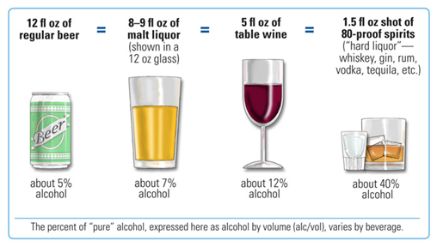 | □ NEVER  □ LESS THAN ONCE A MONTH *  □ ONE TO THREE TIMES PER MONTH *  □ ONE TO THREE TIMES PER WEEK *  □ MORE THAN THREE TIMES PER WEEK *

3. How many times in the past year have you used an illegal drug or used a prescription
medication for non-medical reasons?
□ NEVER | □ LESS THAN ONCE A MONTH * | □ ONE TO THREE TIMES PER MONTH * | □ ONE TO THREE TIMES PER WEEK * | □ MORE THAN THREE TIMES PER WEEK *

* Adapted from the PHQ9, GAD7, NIAAA, and NIDA

For Office Use Only
If 1a +1b ≥ 3 If 1c is ≥ 1 If 1d + e ≥ 3 If 2 or 3 is anything other than NEVER REFER TO BH SPECIALIST
Use PHQ9 Use PHQ9 Use GAD7 Use AUDIT for alcohol and DAST for substances

